Expert Lecture
Academic Year 2022-2023
S.No | Name of the Resource person | Designation and organization | Date organized | Topic covered
1 | Dr.N R Dakshina Murthy | Associate Professor,CBIT,Hyderabad. | 26-08-2022 | NDT and Structural Rehabilitation Case studies
2 | Mr.S.Mani Mohan Trinath | Managing Director, ACE Academy | 30.08.2022 | How to crack ESE/ GATE/PSUs in First Attempt?
3 | Er. S. B. Shankar Rao | Ritered Sp. Engineer | 15.09.2022 | Role of a Civil Engineer in the world
4 | Ch Ravi Kumar | Senior Consultant, National Academy for Construction | 21.10.2022 | Opportunities for Civil Engineering Students
5 | Indrasen Singh | Director of Academics Affairs, NICMAR, Hyderabad | 03.02.2023 | To develop awareness on career opportunities in techno-management sector
6 | B. Santhosh | Manager, Canter CADD, ECIL, Hyderabad | 17.04.2023  AN: 1.30pm-3.30pm | Role of Engineering Software’s for enhanced placements
7 | Ms. Sri Rekha | Senior Consultant, Indian Green Buildings Council Of Confederation of Indian Industry | 02/05/2023 AN: 1.30PM to 3.30PM | Green Building Movement, Green Education & Opportunities.
8 | Dr. N. Srinivasa Rao | Scientist E at Indian National Center for Ocean Information Services (INCOIS) | 05/06/2023 AN: 2.30PM to 4.00PM | The role of satellite technology in monitoring environmental pollutants and pollution

Training Programme
Academic Year 2022-2023
S. No | Name of the Resource person | Designation and Organization | Date organized | Topic covered
1 | Mr. Gladvin | Trainer, Nilaya Architects,Structural comnsultant & construction | 04.07.2022-14.07.2022 | Revit Architecture

Paper Publications

Academic Year : 2022-23

S No | Name of the faculty | Title of the paper | Journal
1 | Dr. V.V. Praveen Kumar | A study on validation of moment curvature relationship of lime sludge based blended cement concrete on numerical modelling (ATENA)
2 | Dr. V.V. Praveen Kumar | study on strength and durability characteristics of nano-silica based blended concrete. | Hybrid Advances
3 | Dr. V.V. Prasanna Kumar | Checking the Adequacy of Signal Timing at an Isolated Signalized Intersection under mixed traffic conditions: A Case study of ECIL Cross Roads Signalized Intersection in Hyderabad City, India | Indian Journal of Natural Sciences
4 | Dr. N.Mahendra | An explanation of the field and petrographic features of granitic rocks in Narsapur area of Medak district, Telangana India. | Materials today: proceedings(Elsevier)
5 | V.Navaneetha &V.Goutham | Investigation of behaviour of concrete on adding crumb rubber | Indian Journal of Natural Sciences
6 | V.Abdul Raffi | Stabilization of back cotton soil using iron ore waste | Science Technology and Development Journal

Industrial visit/Field visit

A.Y.-2022-2023

Industrial visit at “Emergency Steel Staircase-Block 3 -GCET”
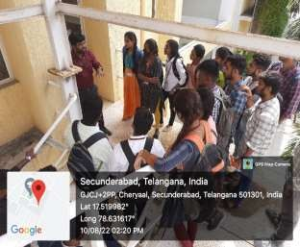
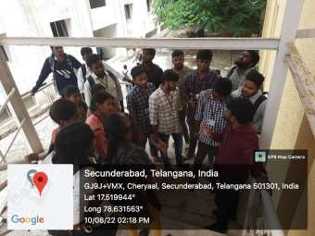
All the B. Tech IV Year students of Civil Engineering were taken to visit the Emergency Steel Staircase at Block-III of GCET on 10th August 2022. Mr. G.Sampath Kumar and Ms.V.Navaneetha ,faculty of Civil Engineering department have accompanied the students for the visit. Students are exposed to understand the importance of rolled steel sections, its connections like welding, bolting and its structural design aspects adopted as per different loading conditions.

- Industrial visit at “National Academy of Construction-Hitech City”
A group of B. Tech II- Year students were taken to National Academy of Construction on 24th December 2022, as part of Curriculum. Students were accompanied by three faculty members. The team of NAC gave a power point presentation on various training programs conducted by the organization. A demonstration on various construction techniques was also given such as Scaffolding, Welding, Plumbing services, prefabricated materials used in industry, Brick masonry, Painting, Electrical wiring, Bar bending schedule etc. Mr. G. Raju, Mr. G. Sampath Kumar and Ms. Reena Rana faculty of Civil Engineering department have accompanied the students for the visit. The visit was highly informative and useful to all the students and the faculty as they got exposed to the practical aspects of construction.
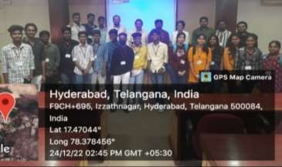
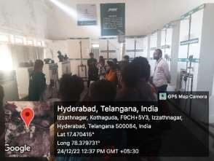

A few snap shots during the visit

Bhaswara
Academic Year 2022-2023

S.No | Event name | Venue | Faculty coordinator  (Name and contact No.) | Student co Ordinator  (Name & Contact No.)
1 | PAPER PREPATION | CAD LAB | 1.Reena Rana  2.DrV.V.Praveen Kumar | 1. V.Aruna 2.N.Swetha
2 | POSTER PRESENTATION | N-219 | 1.Dr.K.Sri laxmi  2.N.Kranthi kumar | 1.Harshitha Goud  Roopa Chandrika
3 | PROJECT EXPO | EG lab | 1.V.Goutham  2.V.Navaneetha | S.Naresh  G.Prashanth
4 | Technical QUIZ | N-209 | 1.G.Raju 2.P.Supriya | 1.P.Lahari 2.Sanjeev
5 | CAD CHAMP | CAD LAB | 1.D.Varun kumar 2.G.Vimala | 1.Bhuvana Chandra 2.Sai ram
6 | TREASURE HUNT | Block-III 3rd Floor | 1.M.Srujan kumar  2. G.Sampath kumar | 1.Harshini Goud  2. Archana
7 | A MINUTE TO WIN | EG lab | 1.V.Navaneetha 2.Reena rana | 1. R.Sai Chetan 2.Devendar

Faculty co coordinator’s: 1) N.Kranthi kumar , Asst. Prof., 2) K.Keerthi Asst. Prof.,
The National Level Technical and Management fest was held on 03-04-2023 and 04-04-2023. The department of Civil Engineering has organized seven events. The particulars of winners are indicted below.

S.No. | Name of the Department | Name of the Event | PRIZE WINNERS LIST
1 | Civil  Engineering | PAPER PREPARATION | Deepa sai
1 | Civil  Engineering | PAPER PREPARATION | Lokesh and sanketha
2 | Civil  Engineering | POSTER PRESENTATION | Lakshmi lavanya
2 | Civil  Engineering | POSTER PRESENTATION | D.Sai ram
3 | Civil  Engineering | PROJECT EXPO | NIL
4 | Civil  Engineering | CAD CHAMP | K. Nikhil
5 | Civil  Engineering | TECHNICAL QUIZ | K.Nikhil and Dheeraj
5 | Civil  Engineering | TECHNICAL QUIZ | B.Naveen kumar
6 | Civil  Engineering | TREASURE HUNT | K.Sai Karthik and R.Chethan
6 | Civil  Engineering | TREASURE HUNT | Devi satya sri and kushalatha
7 |  | MINUTE TO WIN IT | K.Shiva kumar  Sai karthik

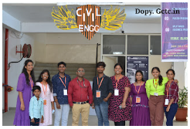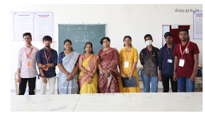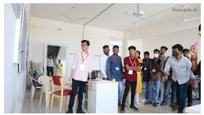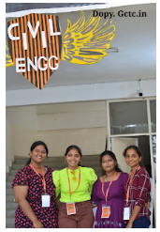

Faculty Achievements/Awards
  - G. Raju, Assistant Professor got admission for Ph. D. under category -II in Osmania University, Hyderabad, Telangana.
  - V. Navaneetha, Assistant Professor got admission for Ph. D. under category -II in Osmania University, Hyderabad, Telangana.

